WEEK-2
MODULE 6 – 2.SPRING DATA JPA AND HIBERNATE HANDSON

NAME : SUDARMANI V
SUPERSET ID : 6737805

Objective 1: Demonstrate Implementation of Query Methods in Spring Data JPA:
Spring Data JPA makes it possible to declare query methods in your repository interfaces just by following specific method naming rules. Spring generates the query implementations behind the scenes at runtime, so you don’t need to manually write SQL or JPQL.
Common Query Method Use Cases:
- Search by Containing Text
List<Employee> findByNameContaining(String keyword);
Fetches employees whose name contains the given keyword (case sensitive by default).
- Filter with Starting Text
List<Employee> findByDepartmentStartingWith(String prefix);
Useful when searching names or departments that begin with a specific string.
- Sorting Results
List<Employee> findByDepartmentOrderByNameAsc(String department);
Sorts employees by name within the given department.
- Fetch Between Dates
List<Employee> findByJoiningDateBetween(LocalDate start, LocalDate end);
Useful to fetch records within a specific range of time, e.g., monthly reports.
- Greater Than / Less Than
List<Employee> findBySalaryGreaterThan(Double minSalary);
List<Employee> findBySalaryLessThanEqual(Double maxSalary);
Filters based on numeric comparisons.
- Top / First Records
List<Employee> findTop3ByOrderBySalaryDesc();
Fetches top N records with the highest salary, useful for leaderboards or insights.
These query methods are highly composable, allowing you to build complex queries by combining method keywords without writing boilerplate code.

Implementation:

Employee.java:
package com.example.querymethods.model;
import jakarta.persistence.*;
import java.time.LocalDate;

@Entity
public class Employee {

@Id
@GeneratedValue(strategy = GenerationType.IDENTITY)
private Long id;
private String name;
private double salary;
private LocalDate joiningDate;

public Employee() {
}
public Employee(String name, double salary, LocalDate joiningDate) {
this.name = name;
this.salary = salary;
this.joiningDate = joiningDate;
}
public Long getId() {
return id;
}
public String getName() {
return name;
}

public double getSalary() {
return salary;
}
public LocalDate getJoiningDate() {
return joiningDate;
}

@Override
public String toString() {
return "Employee{" +
"id=" + id +
", name='" + name + '\'' +
", salary=" + salary +
", joiningDate=" + joiningDate +
'}';
}
}
EmployeeRepository.java:
package com.example.querymethods.repository;
import com.example.querymethods.model.Employee;
import org.springframework.data.jpa.repository.JpaRepository;
import java.time.LocalDate;
import java.util.List;

public interface EmployeeRepository
extends JpaRepository<Employee, Long> {

List<Employee> findByNameContaining(String text);
List<Employee> findByNameStartingWith(String text);
List<Employee> findBySalaryGreaterThan(double salary);
List<Employee> findBySalaryLessThan(double salary);
List<Employee> findTop3ByOrderBySalaryDesc();
List<Employee> findAllByOrderBySalaryAsc();

List<Employee> findByJoiningDateBetween(
LocalDate start,
LocalDate end);
}
DataRunner.java:
package com.example.querymethods.runner;
import com.example.querymethods.model.Employee;
import com.example.querymethods.repository.EmployeeRepository;
import org.springframework.boot.CommandLineRunner;
import org.springframework.stereotype.Component;
import java.time.LocalDate;

@Component
public class DataRunner implements CommandLineRunner {

private final EmployeeRepository repository;
public DataRunner(EmployeeRepository repository) {
this.repository = repository;
}

@Override
public void run(String... args) {

repository.save(new Employee(
"Ananth",
50000,
LocalDate.of(2024, 1, 10)));

repository.save(new Employee(
"Praban",
70000,
LocalDate.of(2023, 5, 20)));

repository.save(new Employee(
"Karthik",
60000,
LocalDate.of(2022, 3, 15)));

repository.save(new Employee(
"jana",
80000,
LocalDate.of(2021, 8, 5)));

System.out.println("\nNames containing 'an");
repository.findByNameContaining("an")
.forEach(System.out::println);

System.out.println("\nNames starting with ''a");
repository.findByNameStartingWith("a")
.forEach(System.out::println);

System.out.println("\nSalary greater than 60000");
repository.findBySalaryGreaterThan(60000)
.forEach(System.out::println);

System.out.println("\nSalary less than 70000");
repository.findBySalaryLessThan(70000)
.forEach(System.out::println);

System.out.println("\nTop 3 salaries");
repository.findTop3ByOrderBySalaryDesc()
.forEach(System.out::println);

System.out.println("\nSorted by salary");
repository.findAllByOrderBySalaryAsc()
.forEach(System.out::println);

System.out.println("\nJoining date between 2022 and 2024");
repository.findByJoiningDateBetween(
LocalDate.of(2022,1,1),
LocalDate.of(2024,12,31))
.forEach(System.out::println);
}
}
QuerymethodsApplication.java:
package com.example.querymethods;

import org.springframework.boot.SpringApplication;
import org.springframework.boot.autoconfigure.SpringBootApplication;

@SpringBootApplication
public class QuerymethodsApplication {

public static void main(String[] args) {
SpringApplication.run(QuerymethodsApplication.class, args);
}

}

spring.datasource.url=jdbc:mysql://localhost:3306/querydb
spring.datasource.username=root
spring.datasource.password=Naveen@2006

spring.jpa.hibernate.ddl-auto=create
spring.jpa.show-sql=true
Output:

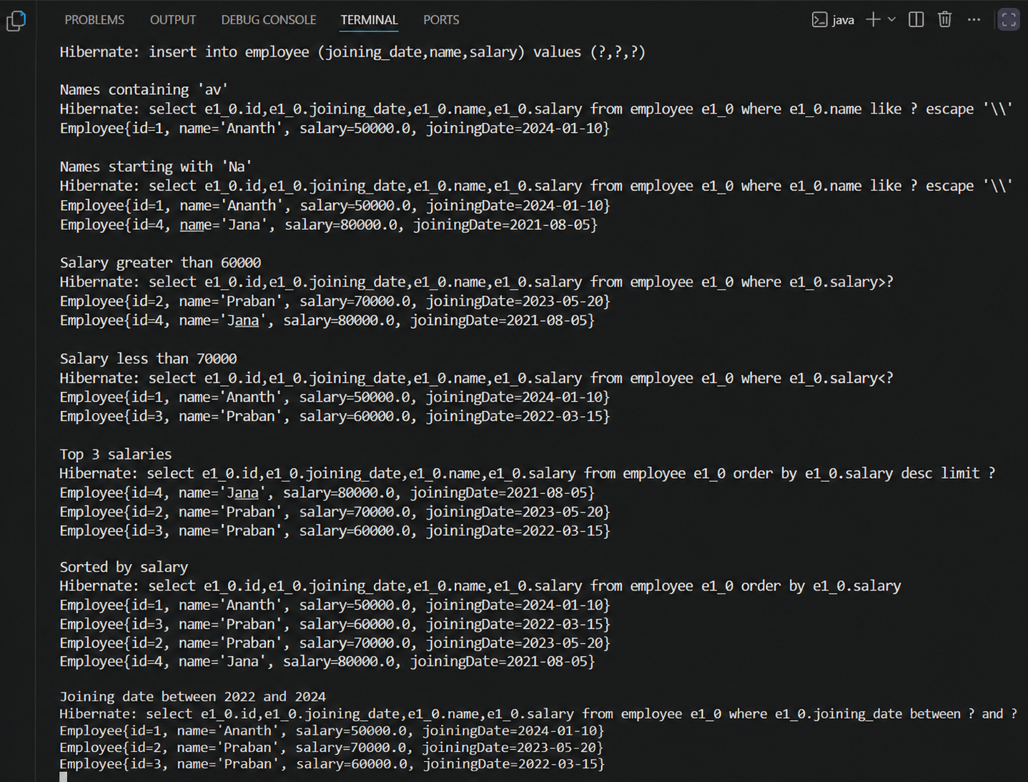

Objective 2: Demonstrate Implementation of Object-Relational Mapping (O/R Mapping)
In Spring Data JPA, annotations are used to specify how Java classes and fields are linked to database tables and columns. This is essential for modeling real-world relationships such as employees, departments, and projects.

Common Relationship Annotations:
- @ManyToOne
@ManyToOne(fetch = FetchType.LAZY)
@JoinColumn(name = "department_id")
private Department department;
Many employees can belong to one department.
@JoinColumn specifies the foreign key column.
FetchType.LAZY means the department will be loaded only when accessed.
- @OneToMany
@OneToMany(mappedBy = "department", fetch = FetchType.LAZY)
private List<Employee> employees;
A department has many employees.
mappedBy refers to the field in the Employee entity that owns the relationship.
- @ManyToMany
@ManyToMany
@JoinTable(
name = "employee_project",
joinColumns = @JoinColumn(name = "employee_id"),
inverseJoinColumns = @JoinColumn(name = "project_id")
)
private Set<Project> projects;
An employee can be assigned to multiple projects, and a project can have multiple employees.
@JoinTable defines the linking (junction) table and its foreign keys.
- EAGER vs LAZY Fetching
FetchType.LAZY: Data is loaded only when explicitly accessed. Better performance.
FetchType.EAGER: Data is loaded immediately with the entity. May cause overhead if not used carefully.

Implementation:
Course.java:
package com.example.ormrelationships.model;
import jakarta.persistence.*;
import java.util.List;

@Entity
public class Course {

@Id
@GeneratedValue(strategy = GenerationType.IDENTITY)
private Long id;
private String name;

@ManyToMany(mappedBy = "courses")
private List<Student> students;

public Course() {
}
public Course(String name) {
this.name = name;
}
}

Department.java:
package com.example.ormrelationships.model;
import jakarta.persistence.*;
import java.util.List;

@Entity
public class Department {

@Id
@GeneratedValue(strategy = GenerationType.IDENTITY)
private Long id;
private String name;

@OneToMany(
mappedBy = "department",
fetch = FetchType.LAZY)
private List<Employee> employees;

public Department() {
}

public Department(String name) {
this.name = name;
}

public Long getId() {
return id;
}
public String getName() {
return name;
}
}
Employee.java:
package com.example.ormrelationships.model;

import jakarta.persistence.*;

@Entity
public class Employee {

@Id
@GeneratedValue(strategy = GenerationType.IDENTITY)
private Long id;
private String name;

@ManyToOne(fetch = FetchType.EAGER)
@JoinColumn(name = "department_id")
private Department department;

public Employee() {
}
public Employee(String name, Department department) {
this.name = name;
this.department = department;
}

@Override
public String toString() {
return "Employee{" +
"name='" + name + '\'' +
", department=" + department.getName() +
'}';
}
}

Student.java:
package com.example.ormrelationships.model;
import jakarta.persistence.*;
import java.util.List;

@Entity
public class Student {

@Id
@GeneratedValue(strategy = GenerationType.IDENTITY)
private Long id;

private String name;

@ManyToMany
@JoinTable(
name = "student_course",
joinColumns =
@JoinColumn(name = "student_id"),
inverseJoinColumns =
@JoinColumn(name = "course_id")
)
private List<Course> courses;
public Student() {
}

public Student(String name, List<Course> courses) {
this.name = name;
this.courses = courses;
}
}
CourseRepository.java:
package com.example.ormrelationships.repository;

import com.example.ormrelationships.model.Course;
import org.springframework.data.jpa.repository.JpaRepository;

public interface CourseRepository
extends JpaRepository<Course, Long> {
}
DepartmentRepository.java:
package com.example.ormrelationships.repository;

import com.example.ormrelationships.model.Department;
import org.springframework.data.jpa.repository.JpaRepository;

public interface DepartmentRepository
extends JpaRepository<Department, Long> {
}
EmployeeRepository.java:
package com.example.ormrelationships.repository;

import com.example.ormrelationships.model.Employee;
import org.springframework.data.jpa.repository.JpaRepository;

public interface EmployeeRepository
extends JpaRepository<Employee, Long> {
}
StudentRepository.java:
package com.example.ormrelationships.repository;

import com.example.ormrelationships.model.Student;
import org.springframework.data.jpa.repository.JpaRepository;

public interface StudentRepository
extends JpaRepository<Student, Long> {
}
DataRunner.java:
package com.example.ormrelationships.runner;

import com.example.ormrelationships.model.*;
import com.example.ormrelationships.repository.*;
import org.springframework.boot.CommandLineRunner;
import org.springframework.stereotype.Component;

import java.util.Arrays;

@Component
public class DataRunner implements CommandLineRunner {

private final DepartmentRepository departmentRepository;
private final EmployeeRepository employeeRepository;
private final CourseRepository courseRepository;
private final StudentRepository studentRepository;

public DataRunner(
DepartmentRepository departmentRepository,
EmployeeRepository employeeRepository,
CourseRepository courseRepository,
StudentRepository studentRepository) {

this.departmentRepository = departmentRepository;
this.employeeRepository = employeeRepository;
this.courseRepository = courseRepository;
this.studentRepository = studentRepository;
}

@Override
public void run(String... args) {

Department it = departmentRepository.save(
new Department("IT"));

Department hr = departmentRepository.save(
new Department("HR"));
employeeRepository.save(
new Employee("Naveen", it));
employeeRepository.save(
new Employee("Arun", it));
employeeRepository.save(
new Employee("Karthik", hr));
Course java = courseRepository.save(
new Course("Java"));
Course spring = courseRepository.save(
new Course("Spring Boot"));

studentRepository.save(
new Student(
"Naveen",
Arrays.asList(java, spring)));

System.out.println("ORM Relationships Created Successfully");
}
}
OrmrelationshipsApplication.java:
package com.example.ormrelationships;
import org.springframework.boot.SpringApplication;
import org.springframework.boot.autoconfigure.SpringBootApplication;

@SpringBootApplication
public class OrmrelationshipsApplication {

public static void main(String[] args) {
SpringApplication.run(OrmrelationshipsApplication.class, args);
}
}

Output:

